1. **Agenda:**
   1. How Consumer manages the **Consumer Offset**.
2. Make sure the Kafka Cluster is up and running.
3. Run the Consumer App.
4. Publish the records.   
   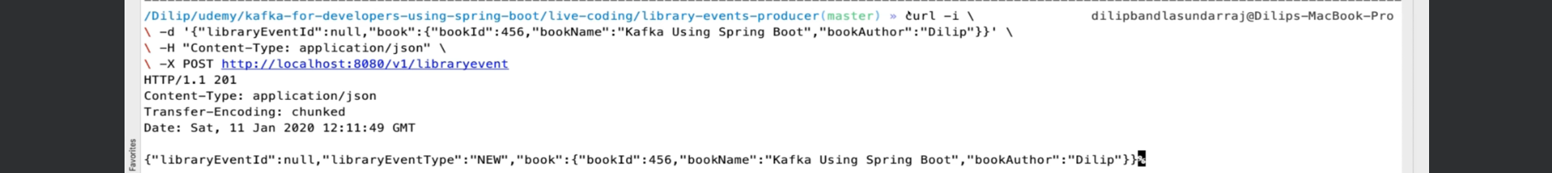  
   Post 3 records.
5. Consumer Console has those 3 records.   
   
6. Shut Down the Consumer.
7. When we bring it up again, it is not reading those already read records.  
   How does it work actually?
8. 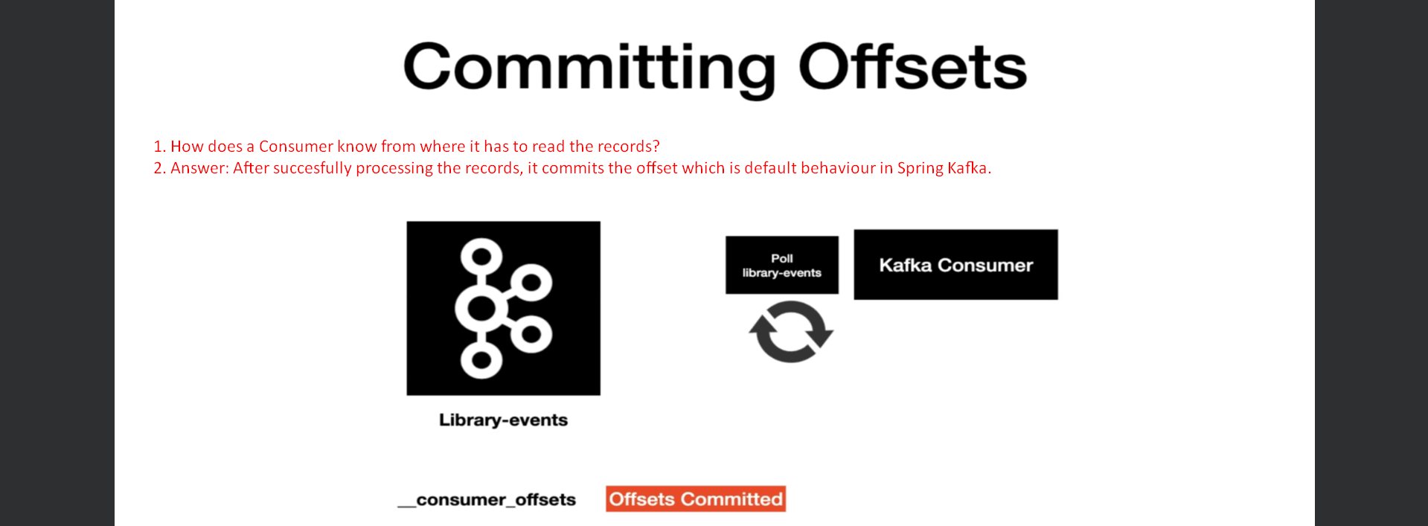
9. Let’s see how to change this default behaviour.
10. 